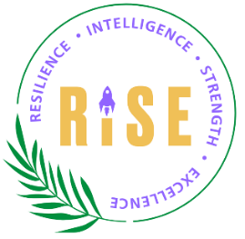

Programme Overview

The RISE Programme supports Mid and South Essex Integrated Care System (MSE ICS) its Workforce Race Equality Standard (WRES) and Equality Act 2010 obligations. It enhances business performance by empowering Global Majority staff to overcome challenges and contribute to high-quality healthcare in a rapidly changing environment. The programme also helps achieve the Model Employer Aspiration by developing diverse talents and representation for senior leadership roles.
Programme Benefits
- Diversify leadership by advancing skilled Global Majority staff into senior positions.
- Enhance staff skills and knowledge.
- Improve recruitment, retention, creativity, and staff engagement.
- Build a Global Majority talent pool.
- Support MSE ICS Quality and Safety Strategy. Address the career progression gap identified in the Workforce Race Equality Standard (WRES) 2023 report.

Programme Details
Duration: One day per month for 4 months, plus additional workshops for quality improvement facilitation (mandatory for all participants).
Participants: Clinical and non-clinical bands 2–8a from Global Majority backgrounds.
Line manager requirement: Must attend the Line Manager workshop and support participants.
Project: Participants will complete a project that adds value to their work area.
Support for Participants
- Line manager support.
- Ethnic minority, Race equality, and Global Majority Staff Networks.
- Senior Managers from Global majority backgrounds.
- Peer Networks.
Expected Outcomes
- Develop leadership skills and behaviours.
- Improve influencing, negotiation, and self-awareness.
- Build a strong personal profile for greater visibility.
- Strengthen team leadership and stakeholder relationships.
- Join a supportive peer learning network.
- Coaching, mentoring, sponsorship and engagement with executive.

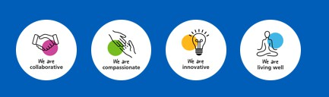
Rising Leaders (Bands 7-8a) Programme Dates

Module 1: 25 November 2025 - What it means to you (Online session)
Module 2: 27 February 2026 - Personal Impact (Face-to-Face)
Module 3: 23 March 2026 - Making Sense of Human Resources (Online session)
Module 4: 27 April 2026 - Rise and Keep Rising (Online session)
Module 5: 29 May 2026 – Leading and Managing with Purpose
Graduation: TBC

